**Assignment -1**

# HOME AUTOMATION

**Question-1:** smart home automation designs provide an unprecedented level of comfort and convenience in Melbourne homes, delivering you a personalised and innovative room experience.

**Solution:**

**void setup()**

**{**

**pinMode(LED_BUILTIN, OUTPUT);**

**Serial.begin(9600);**

**}**

**void loop()**

**{**

**int p = digitalRead(4);**

**Serial.println(p);**

**if(p)**

**Serial.println("Motion detected!!!");**

**if(p==1){ digitalWrite(8, HIGH);**

**delay(1000);**

**}**

**else**

**{digitalWrite(8, LOW);**

**delay(1000);**

**}**

**double a= analogRead(A0);**

**double t= (((a/1024)*5)-0.5)*100;**

**Serial.print("Temp value: ");**

**Serial.println(t);**

**if(t>100)**

**{ digitalWrite(13, HIGH);**

**delay(1000);**

**tone(12, 131);**

**delay(250);**

**noTone(12);**

**delay(125);**

**}**

**else**

**{digitalWrite(13, LOW);**

**delay(1000);**

**}**

**delay(1000);**

**}**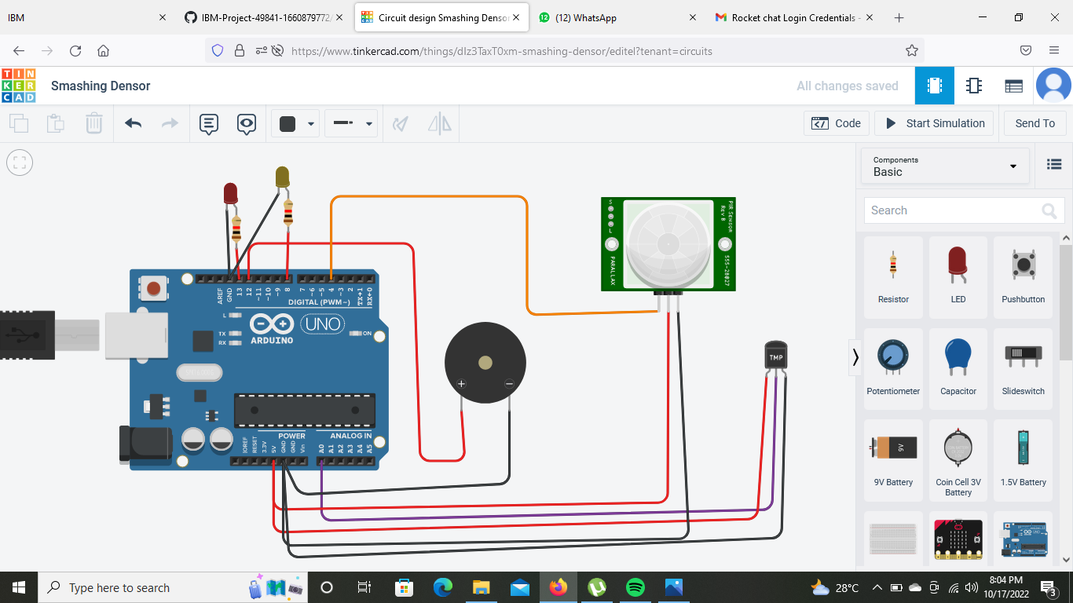

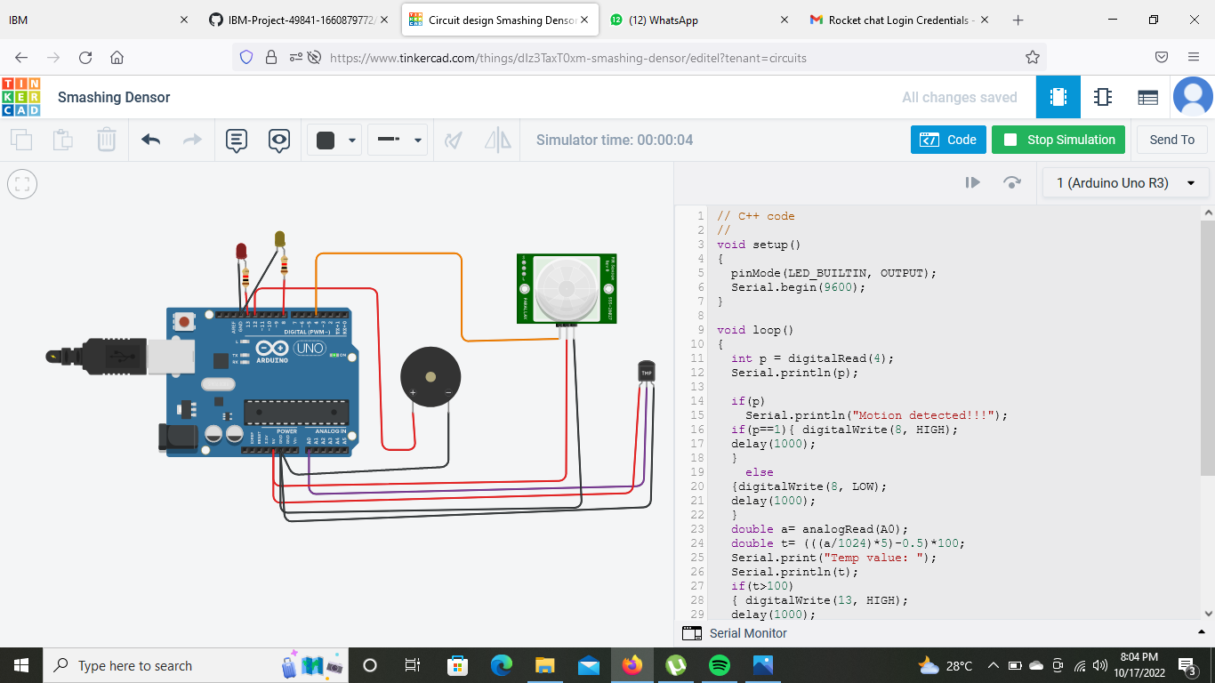

Submitted By

Team Leader; Luckneshwaran E

Team Member 1; Ranjith P

Team Member 2; Vijayakumar S

Team Member 3; Syed Sadham Hossain